RX board verification Procedure

Version 4.0

# Loading and configuring Ubuntu

1. Install Quartus Prime 15.1 see file “QuartusSetup-15.1.0.185-windows”
2. Install Ubuntu 12.04.5 LTS.

On Ubuntu:

sudo apt-get install openssh-server

sudo apt-get install build-essential

sudo apt-get update

sudo apt-get upgade

gcc –v

make –v

sudo apt-get install freeglut3 freeglut3-dev

sudo apt-get install libusb-1.0-0-dev

1. *Install Atmel Studio 7.0*

# Hardware Cable Setup

1. *Set up and make cables connect to PC. See the Pictures:*

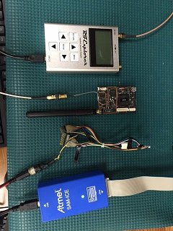

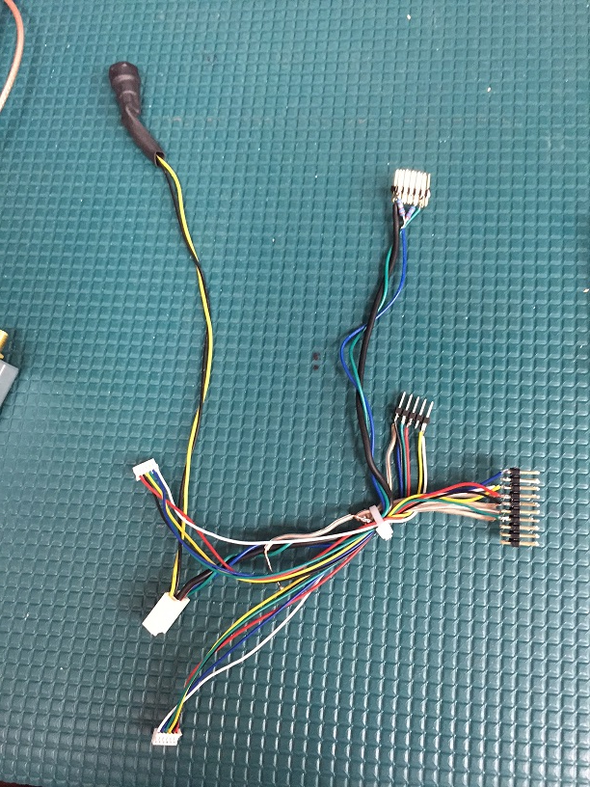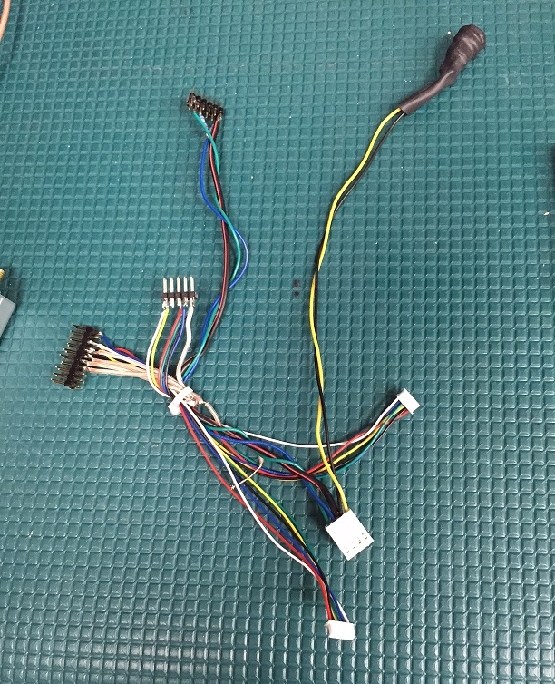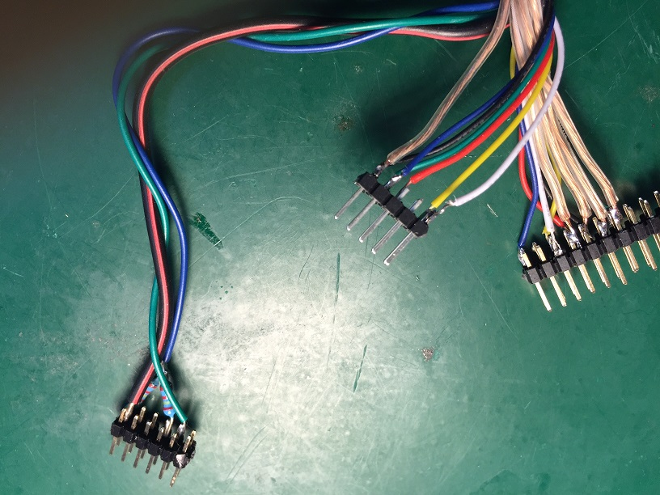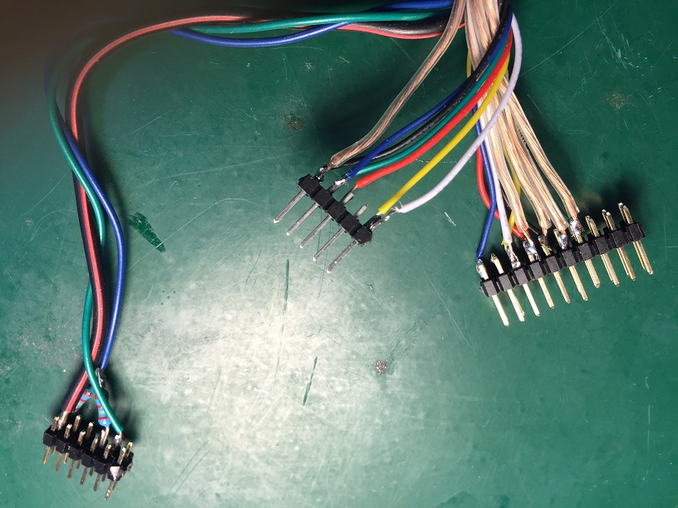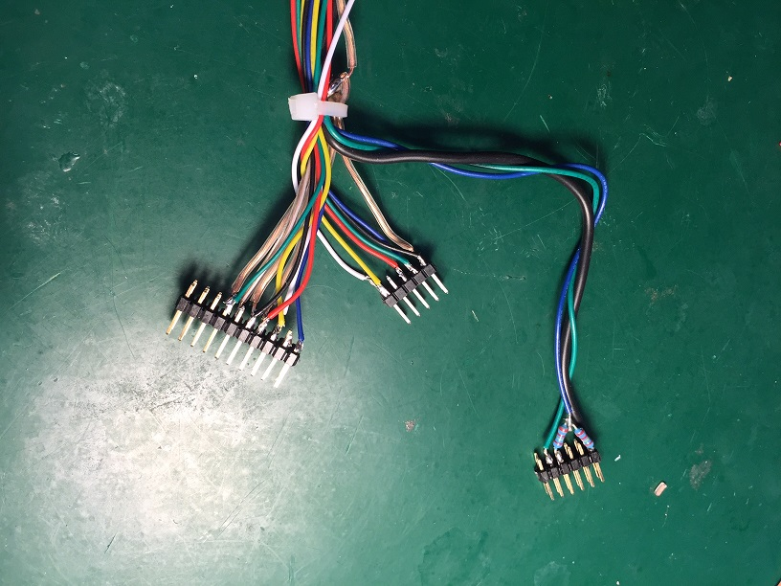

1. Connect all cables and set 5.0V and 0.22A

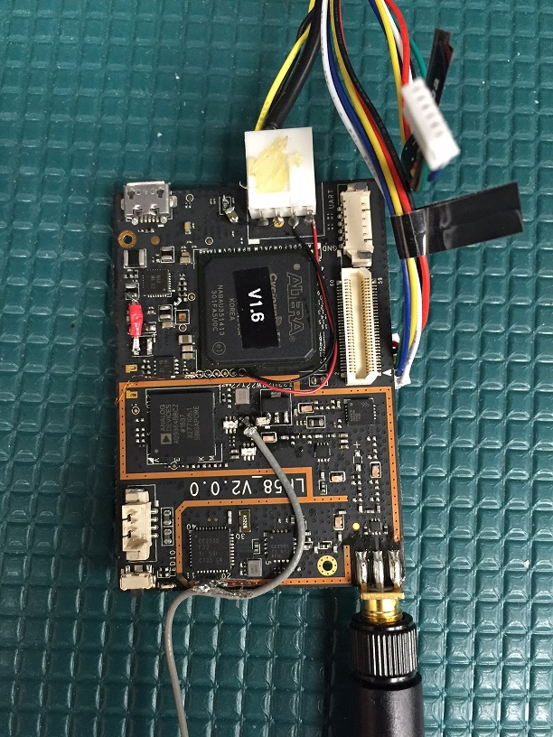

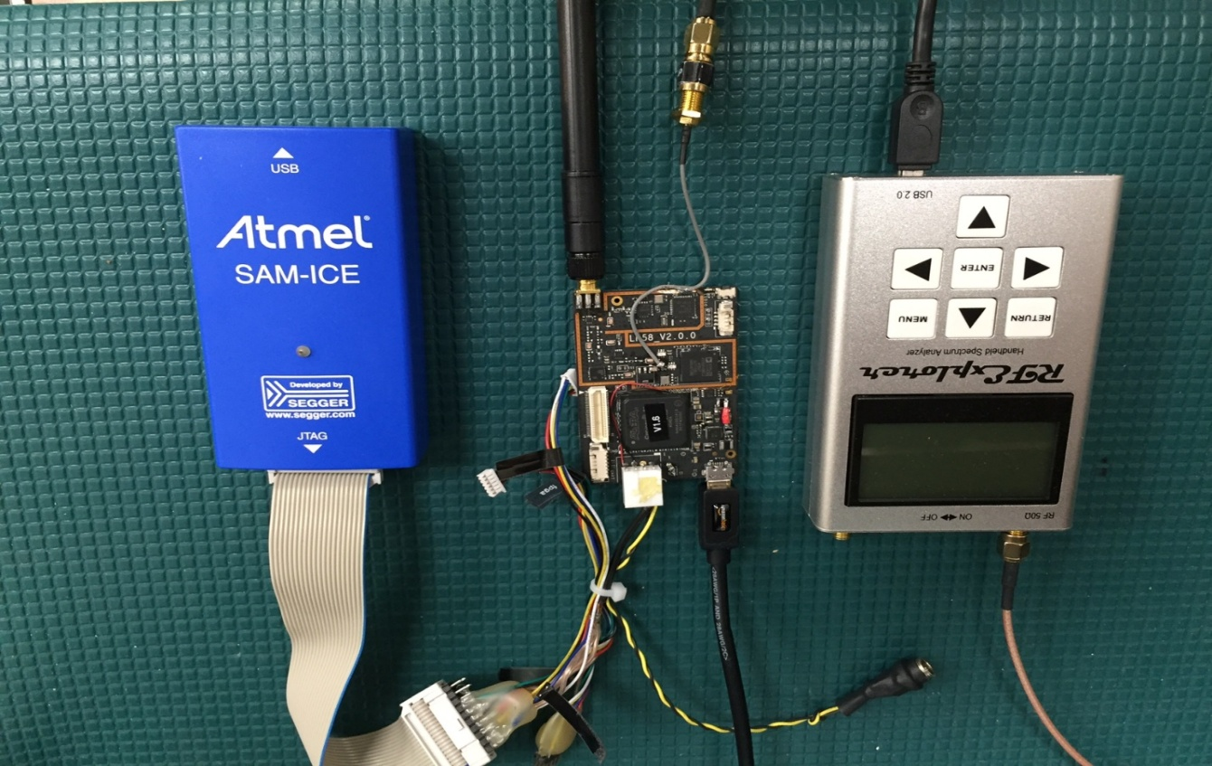

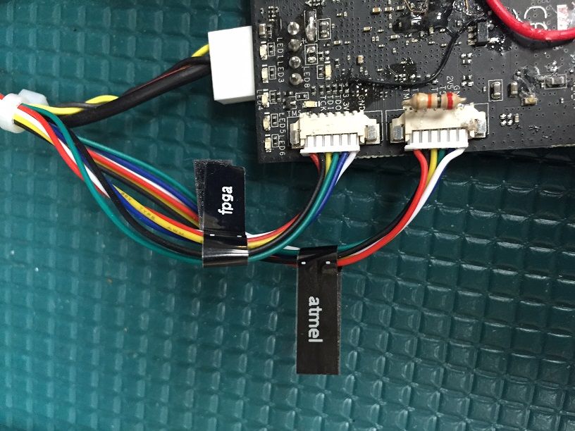

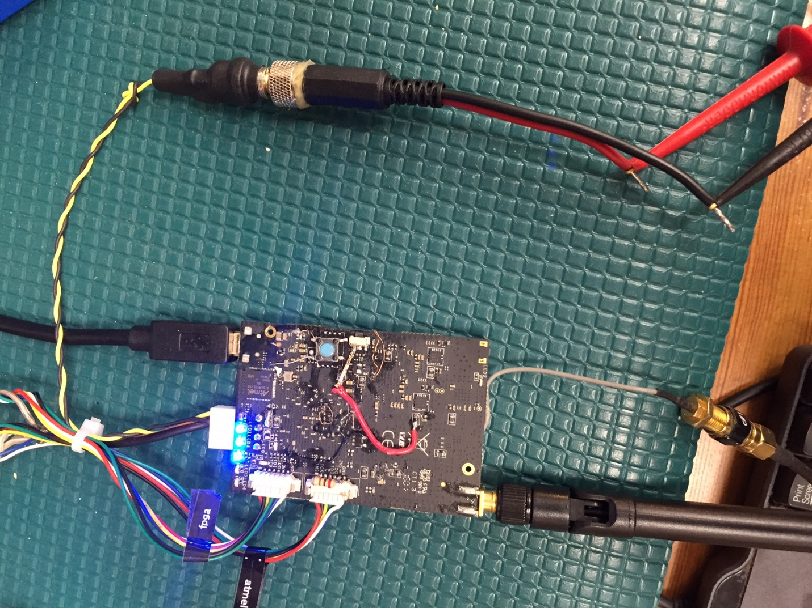

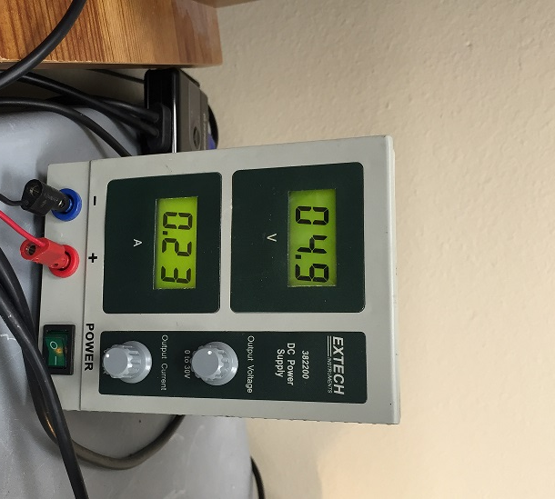

1. Run Quartus:

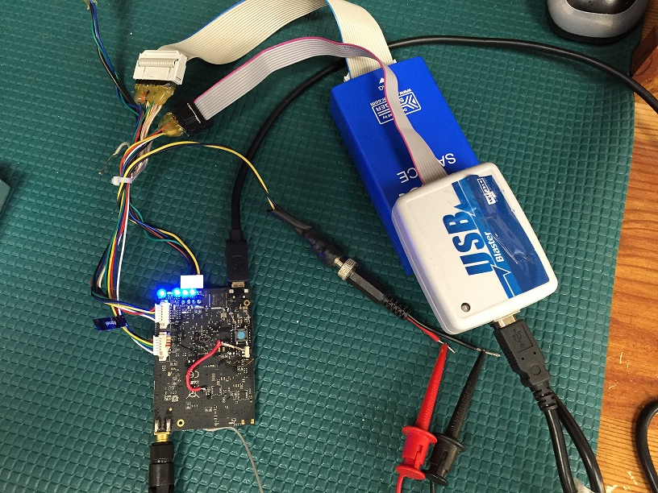

# Flashing FPGA

To flash fpga: Open Quartus

Click on Tool -> Program

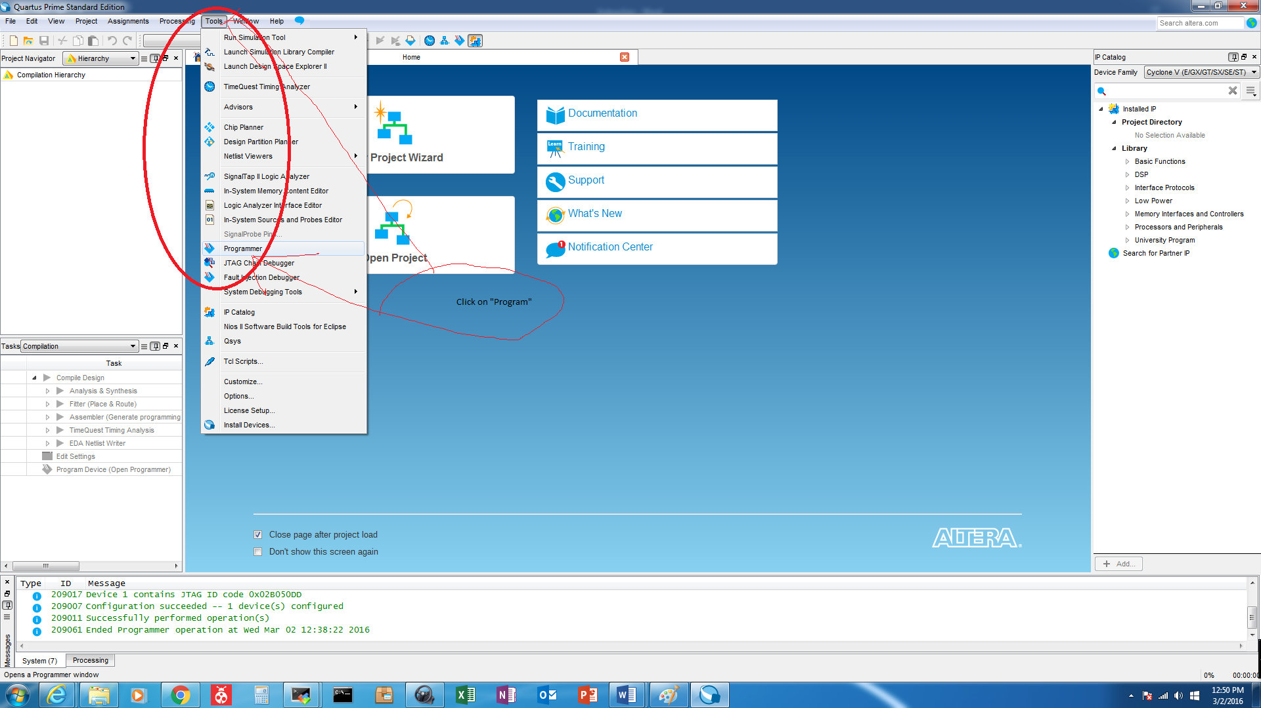

Double Check on “hardware Setup”

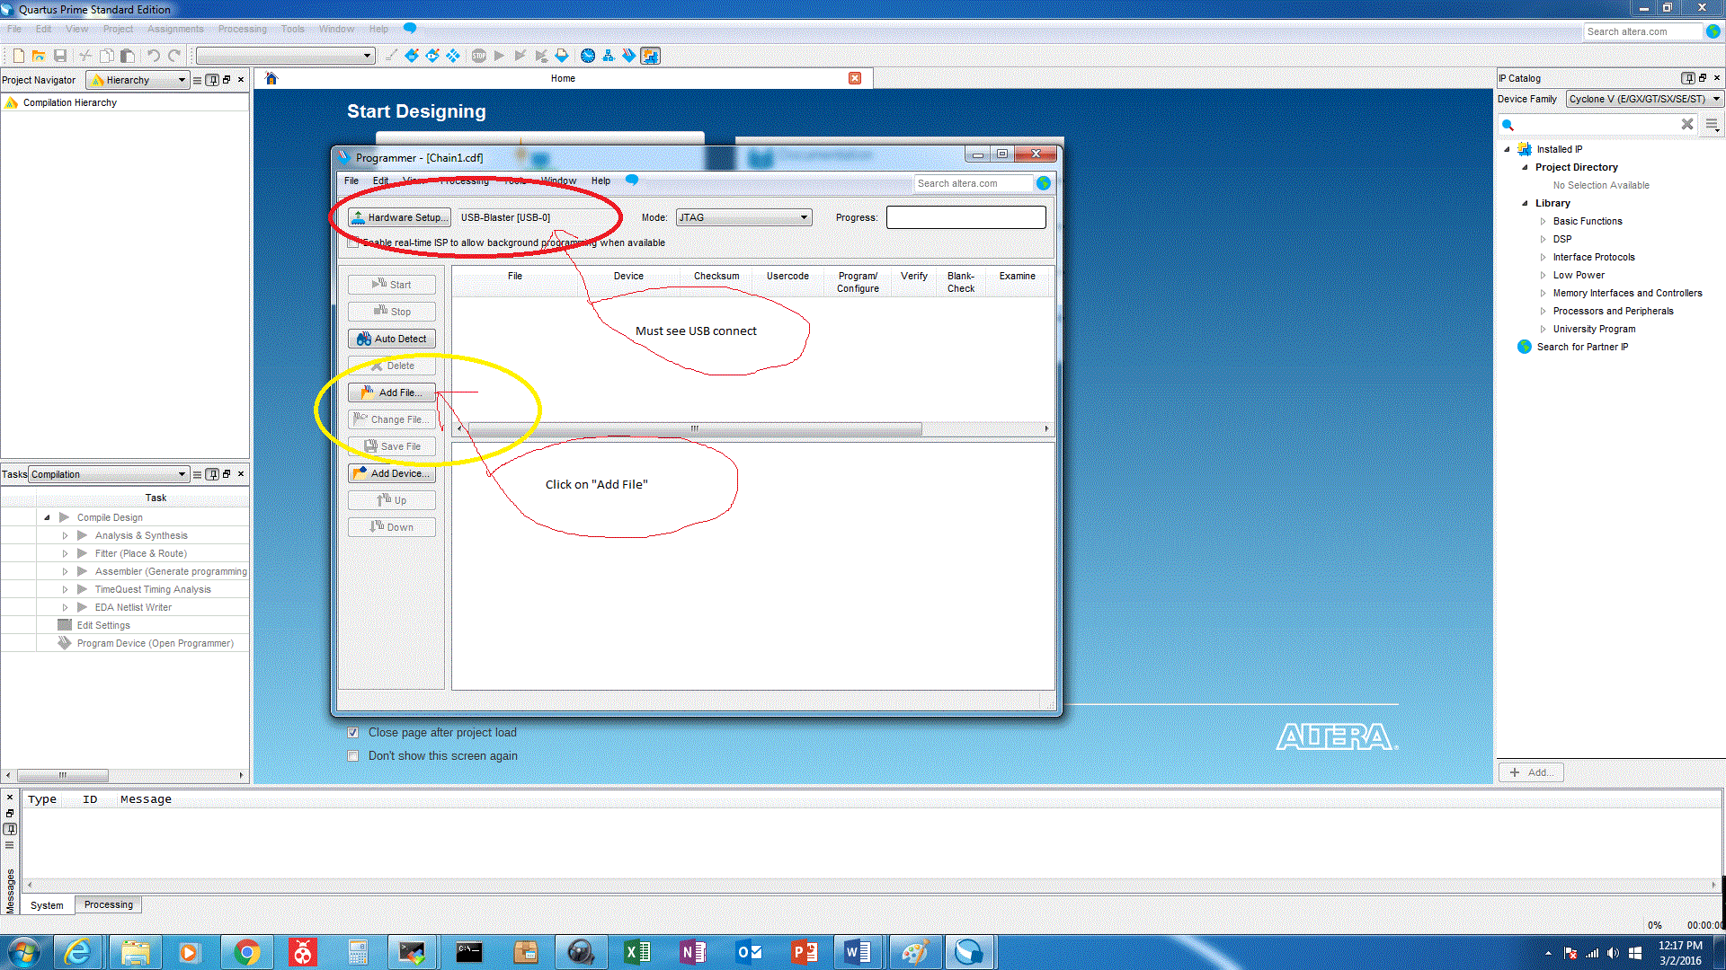



Click on “Add File”

And Brower file: “lgdst_mod_0218.jic”

Picture for file: lgdst_mod_0218.jic

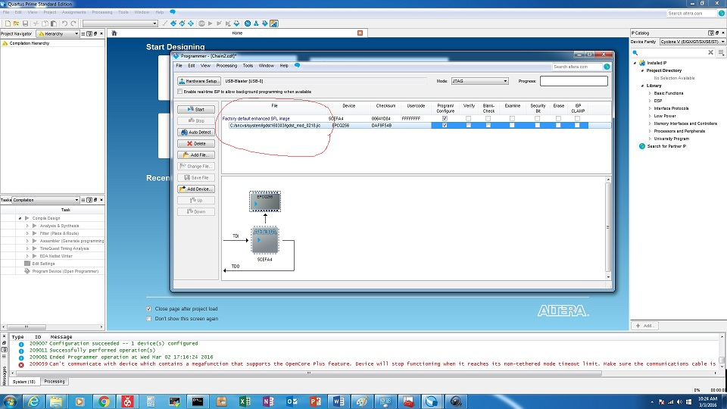

And see the first LED:

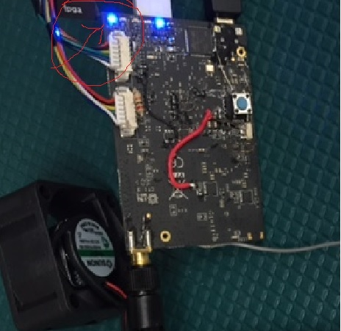

And Brower file: “lgdst_mod_top_time_limited.sof”

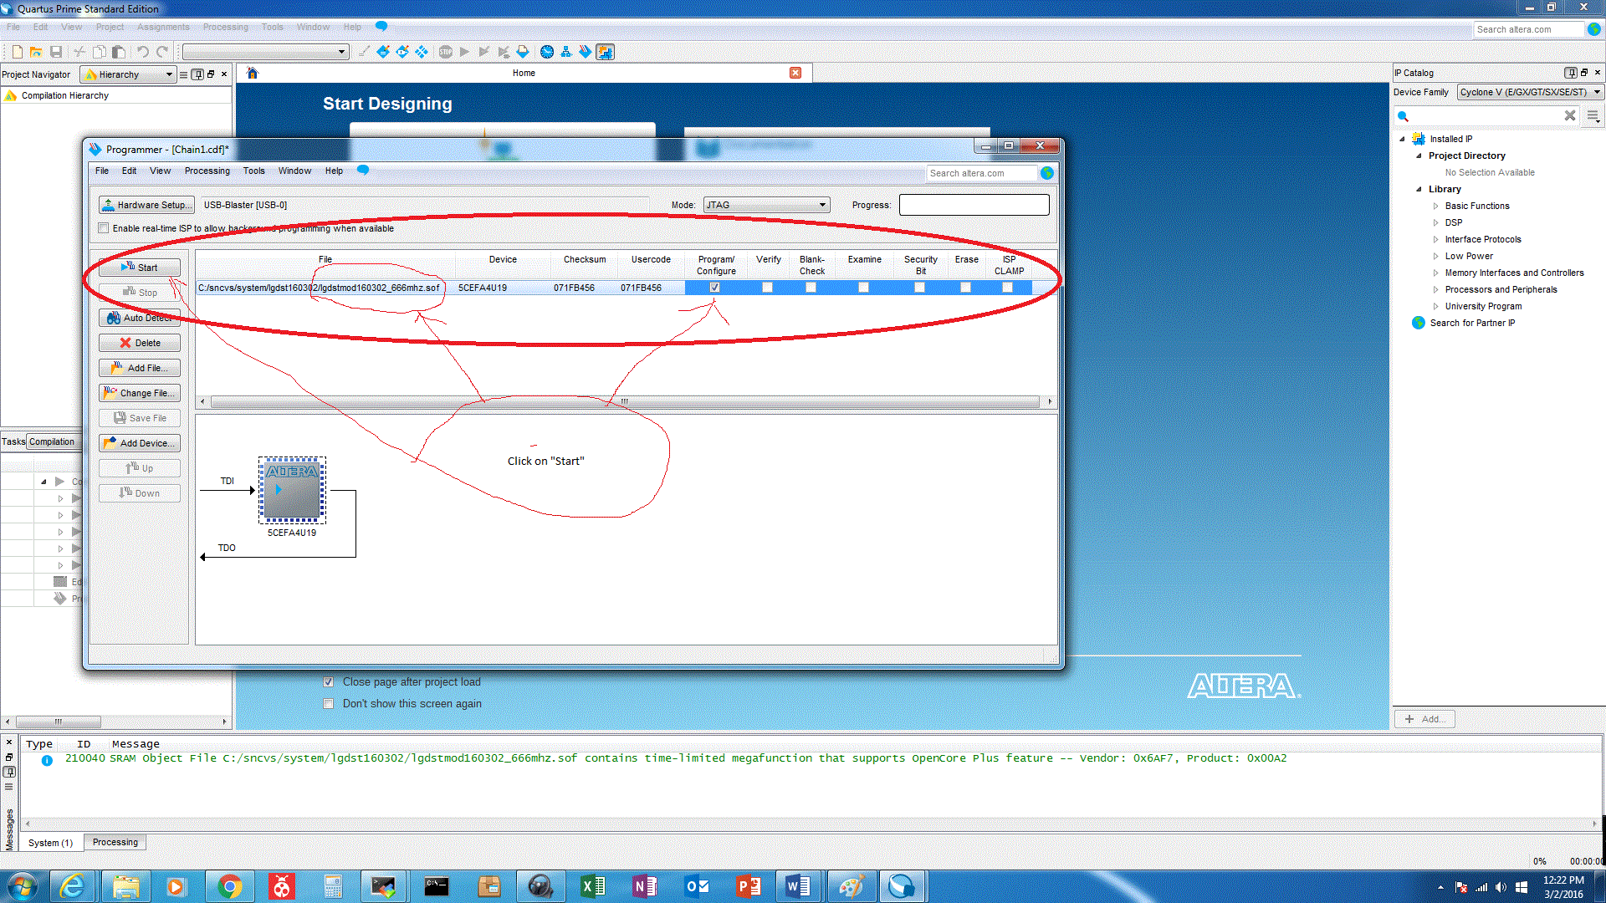

When loaded correctly, should see LED6 blink.

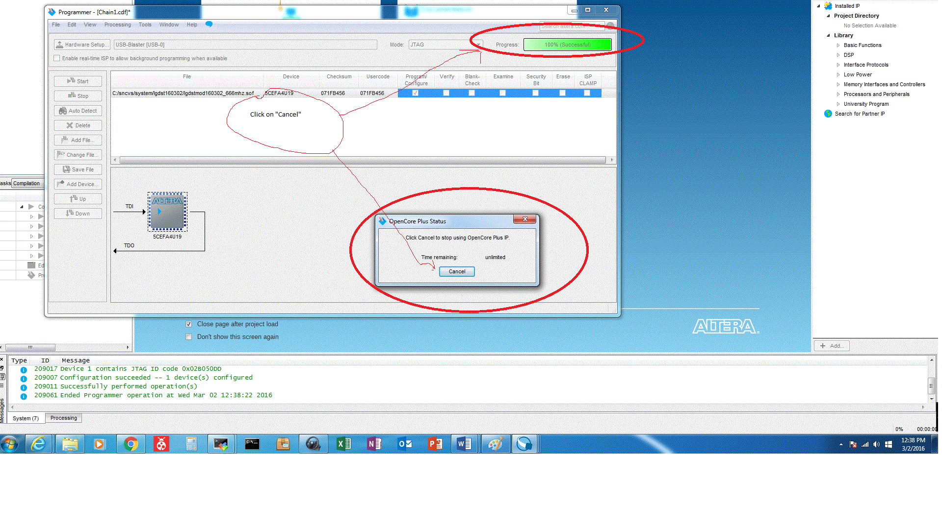

Once loaded, should see RF signal at 2430mhz. This signal is tapped with C147 removed, tapped at AD9364 RF output. And file “lgdst_mod_top_time_limited.sof”

Total current draw: 0.8Amps.

See RF

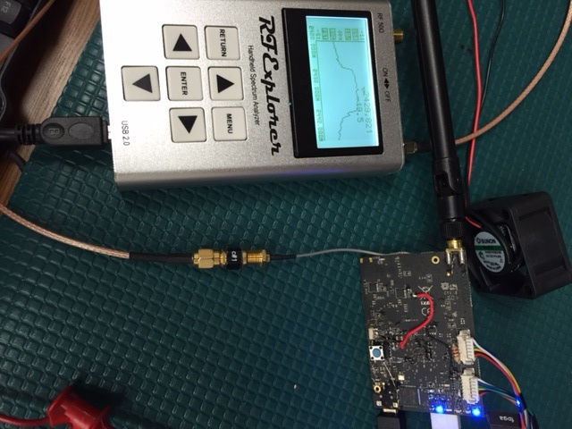

# Running and Loading Atmel Studio 7.0

Open Atmel Studio:

Click on “Tools” and then click on “Device Programming”

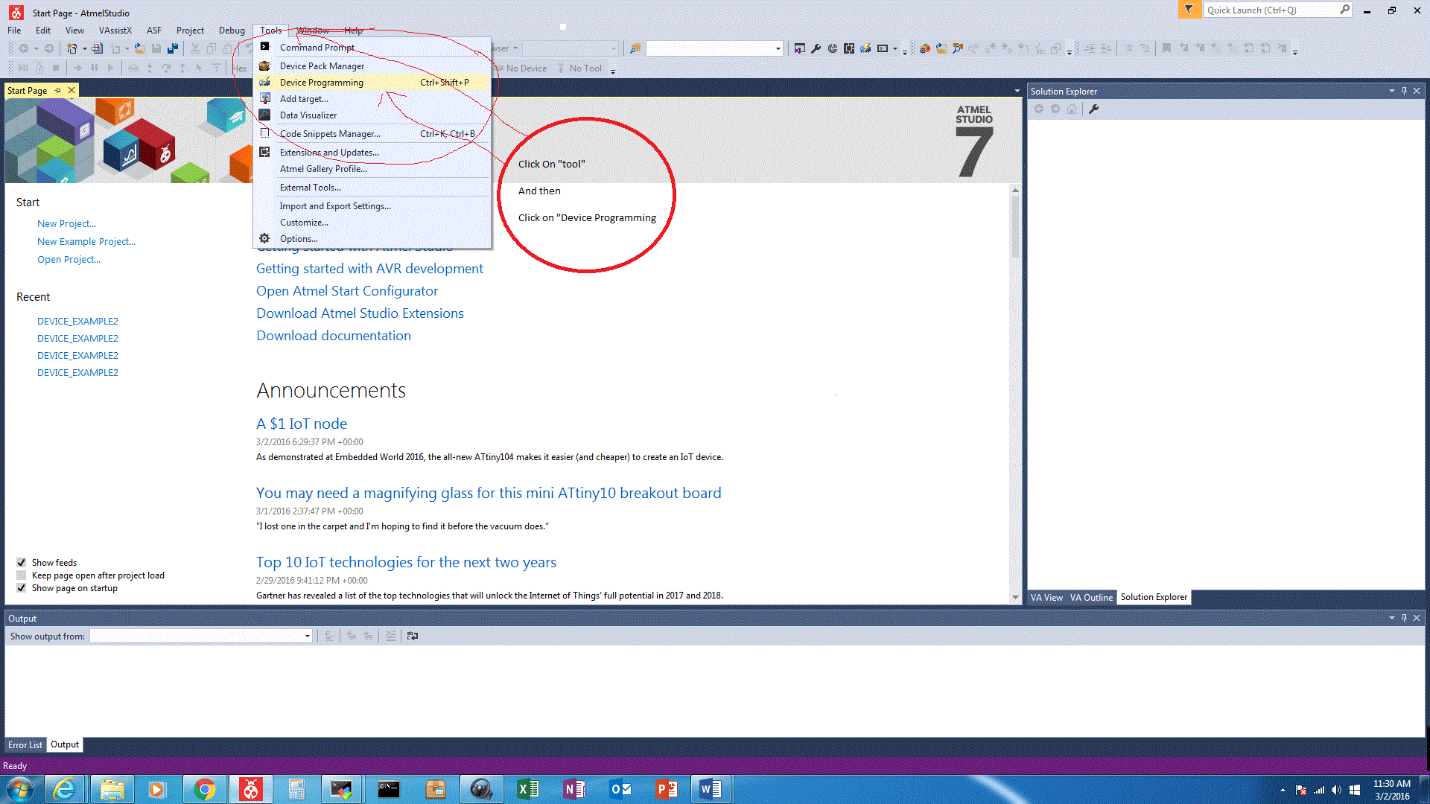

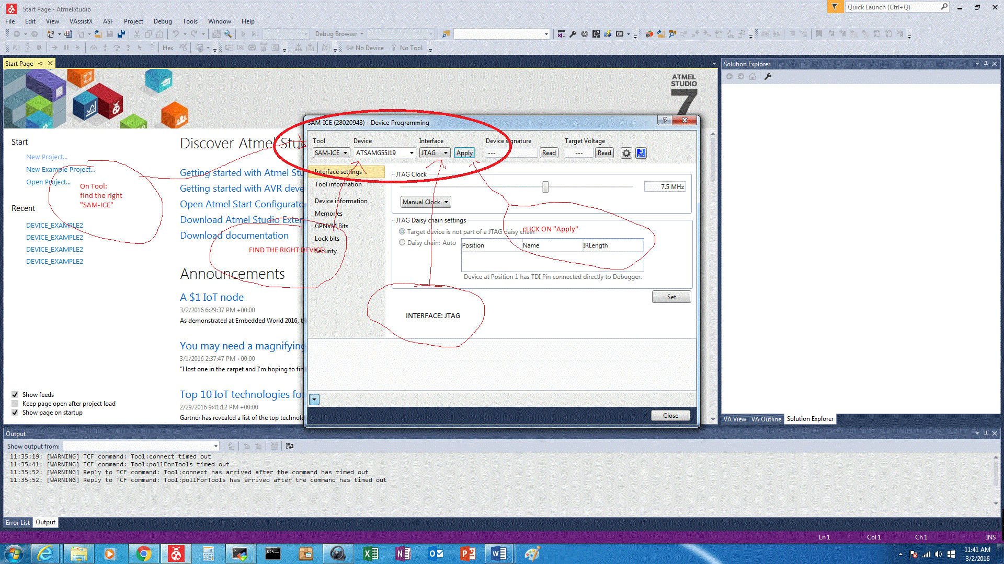

Click 2 times on “Read”

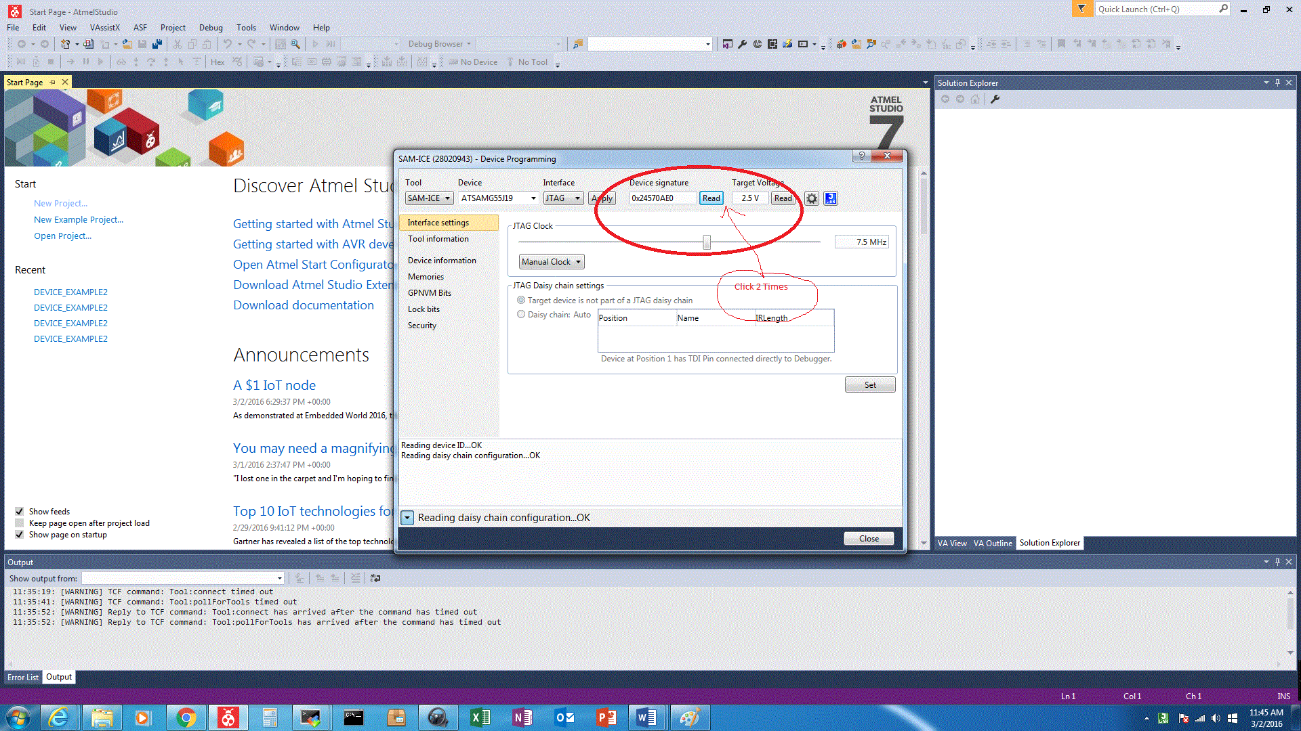

There is a file: “atmeltx160302_txcomplete.elf”

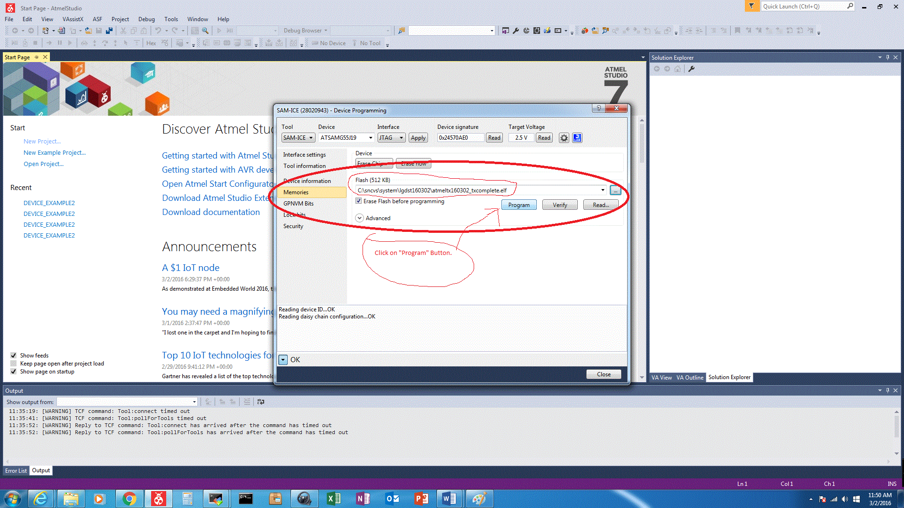

Make sure it is the “txcomplete” version.

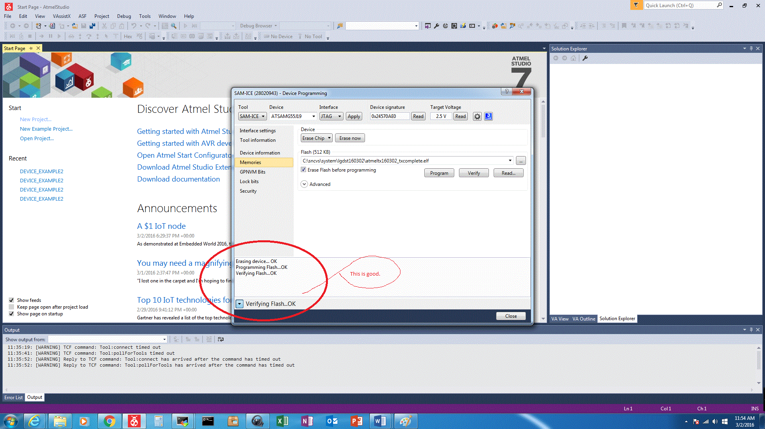

Led Blinking:

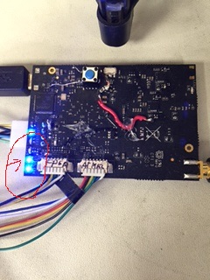

Once loaded correctly, should see LED5 blink.

1. Run Helm1100: Need to have an USB to Serial 0-2.5V converter. Red wire is TX from FPGA, black wire is RX from FPGA.

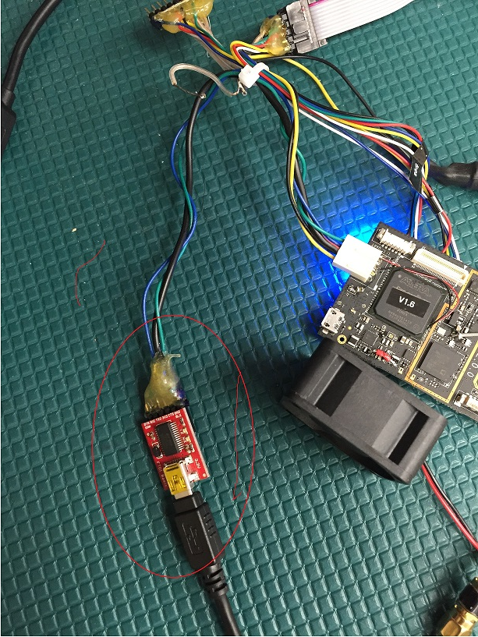

# Loading Helm

Open helm App: When running on XP, must install Microsoft Framework 4.0 or above.

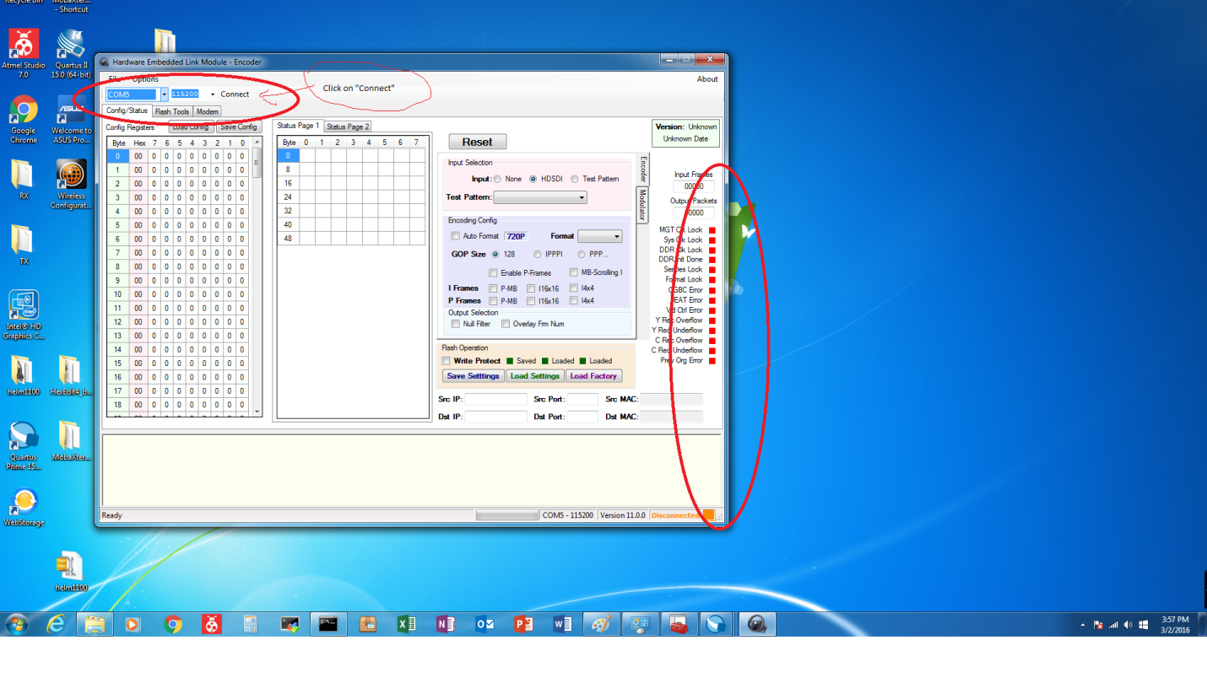

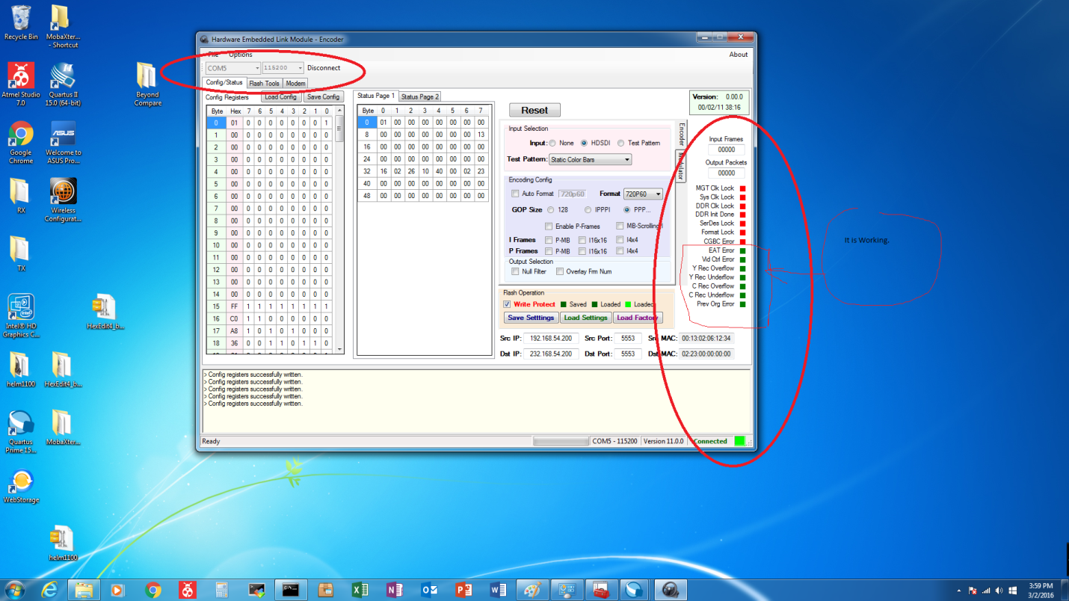

1. Set up for Ubuntu:

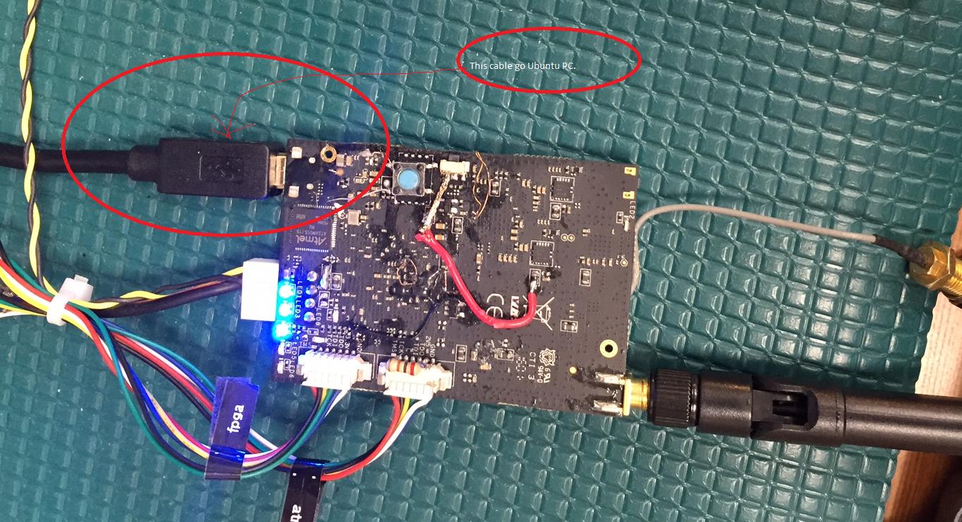

* On Ubuntu:
  + Type “lsusb”, should see Atmel.

# Verify USB Interface functionality

* On Ubuntu:

Tar –xvf linuxhost160301_exe.tar

Cd pkg

Lsusb

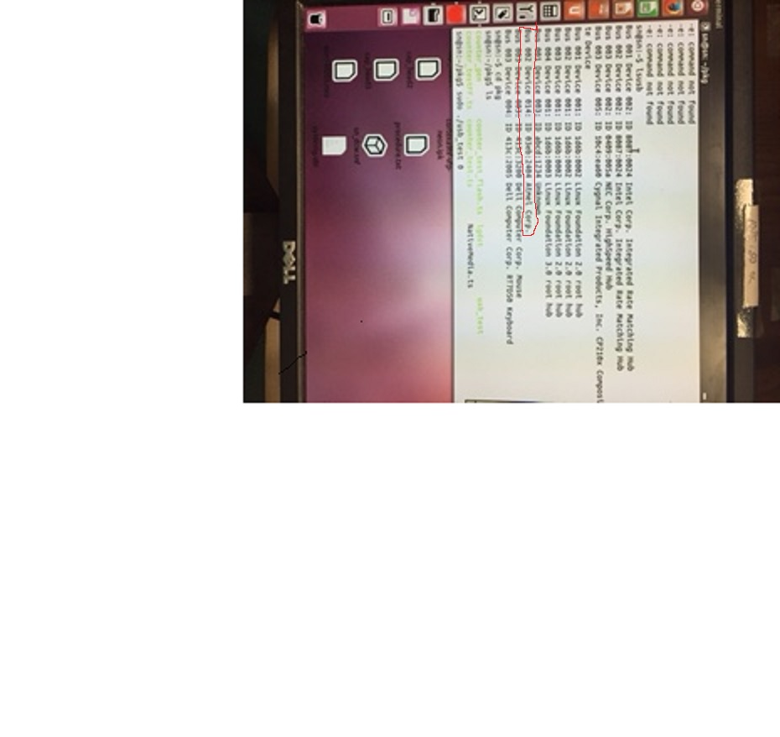

Chmod 777 usb_test

sudo ./usb_test 0

See pkt count increase, hit <CTRL>C when it exceeds 150 count.

Should not see any error messages.

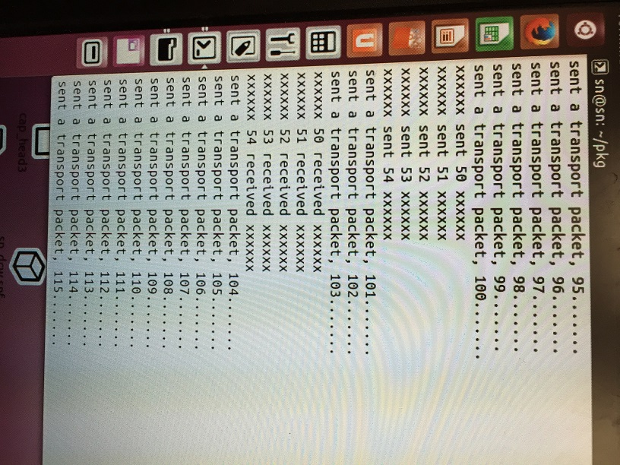

# Moving Box TS pattern Self generating Atmel Procedure

1. Open Atmel Studio
2. Go to Tools ->Program and then program file :” C:\sncvs\system\lgdst160307/movingbox116k.elf”
3. On Ubuntu: untar “spiusb160302_mvbx_exe.tar”
4. cd spiusb160302_mvbx_exe
5. chmod 777 *
6. lsusb
7. sudo ./usb_movebox 0
8. You will see two LEDs on the board running fast.
9. Open Quartus and program file “lgdst_top_2430mhz_dvbt.sof”
10. You will see the signal on RF
11. Open Helm 1102
12. Connect to board by usb to serial port

# USB Based Register Configuration

1. Connect board to Ubuntu through USB

2. Type "lsusb" to verify that Atmel is connected.

3. Copy the file "spiusb160303_fpgaacs_exe.tar.gz to Ubuntu

4. Un tar the file (tar -xvf spiusb160303_fpgaacs_exe.tar.gz)

5. type "sudo ./lgdst" , you should see a set of commands to use.

6. Type "sudo ./lgdst w aa bb" to set a register. aa=register address in hex.

bb=assigned value in hex.

7. Type "sudo ./lgdst r aa" to read back a register. aa=register address in hex.

8. Reg0x4E=highbyte frequency

Reg0x4F=lowbyte frequency

Reg0x48=highbyte attenuation

Reg0x49=lowbyte attenuation

Reg41=update new parameters. An 0x40 will reconfigure the RF output

based on the new frequency/attenuation levels.